
2025
JFed Security

Usher - Greeter Training

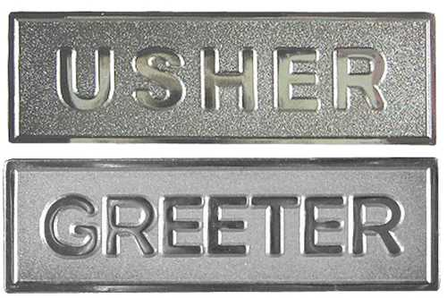



Usher – Greeter Training
Course Description

Usher - Greeter (2hr)
Usher / Greeter training provides the ability to assist professional armed security personnel and community members with recognizing and reacting to suspicious activity and providing communication during critical incidents.

Course Objectives:
- Discuss how the usher/greeter position(s) factor into the total security approach and how it relates to your location.

- Discuss the characteristics of a successful usher/greeter program.

- What usher/greeter responsibilities are concerning the facility's overall security plan.

- How to perform the essential functions of the usher/greeter role during events.



Usher – Greeter Training
Course Outline

- Goals and Objectives of the training

  - Discuss how the usher/greeter position(s) factor into the total security approach and how it relates to your location.
  - Discuss the characteristics of a successful usher/greeter program.
  - What usher/greeter responsibilities are concerning the facility's overall security plan.
  - How to perform the essential functions of the usher/greeter role during events.

- An Usher–Greeter program is a critical part of an overall security plan.

  - Observe
  - Communicate
  - Respond

- Usher - Greeter Roles and Responsibilities

  - Definition of Usher and Greeter
  - Who should serve in each position
  - Roles and Responsibilities of each position

- Usher - Greeter Roles and Positioning

  - Positioning as it relates to each location

- The Power of “Hello”

  - How to utilize “Hello” correctly
  - If trained correctly the “power of hello” can assist

    - Observe
    - Assess
    - Obtain Help

- Strategies for dealing with Individuals in Crisis

- Summary

