
Stop the Bleed Training
2025
JFed Security

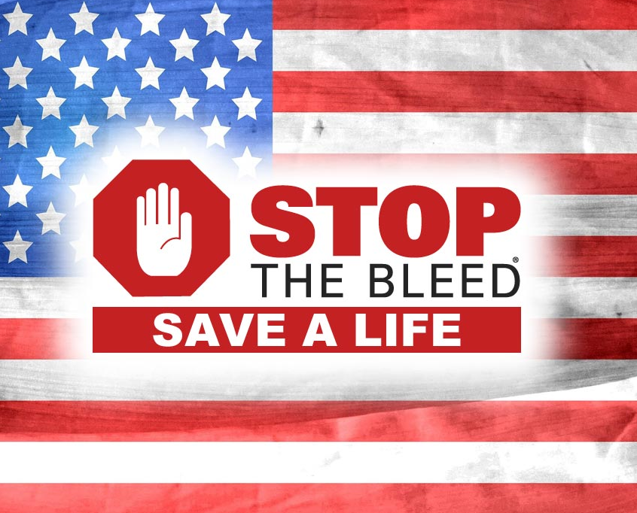



Stop the Bleed
Course Description
Stop the Bleed (2hr)
According to the Centers for Disease Control, the number one cause of preventable death after injury is bleeding. This training will provide the ability to recognize life-threatening bleeding and act quickly and effectively to control bleeding.

Course Objectives:
- Instruct people on how to control life-threatening bleeding until first responders arrive on location to render aid.

- Instruct people on the use of direct pressure, tourniquets, and wound packing to treat bleeding after a traumatic injury.

- Instruct the three quick techniques to help save a life before someone bleeds out.

  - How to utilize your hands to apply pressure to a wound.
  - How to pack a wound to control bleeding.
  - How to correctly apply a tourniquet.



Stop the Bleed
Course Outline

- Goals and Objectives of the training
  - Recognize life-threatening bleeding.

  - Take steps to stop the bleeding with the utilization of:
    - Pressure
    - Packing
    - Tourniquet

- Review of personal safety

- ABCs of Bleeding Control

  - Alert 9-1-1
  - Bleeding
  - Compress
    - Pressure
    - Packing
    - Tourniquet

- Review / Recommendation of Tourniquet(s)

- Bleeding Control in Children

- Summary

