
Basic Life Support / Cardiopulmonary Resuscitation (CPR)
JFed Security

2025

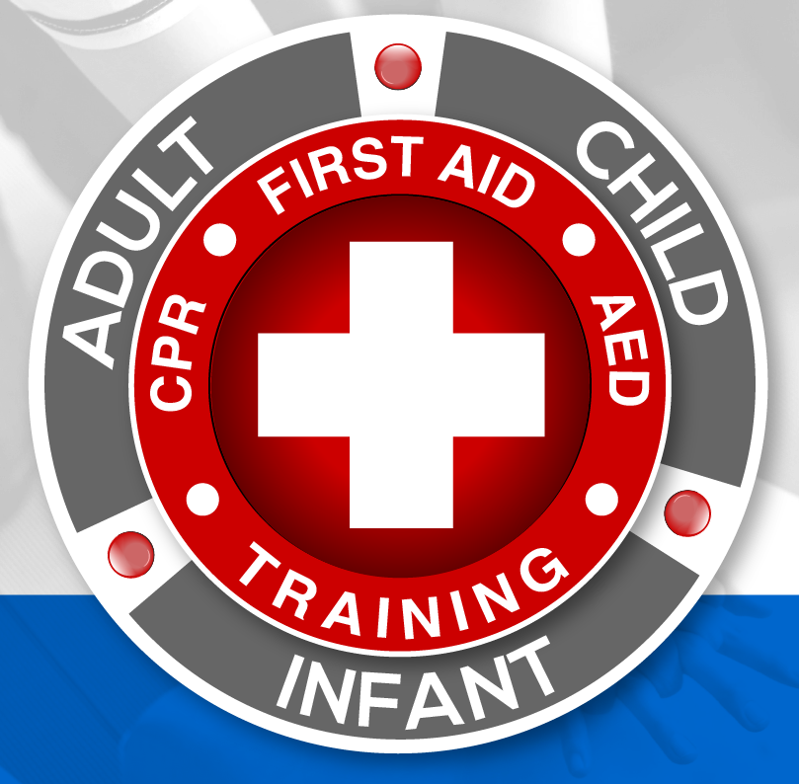


Basic Life Support & Cardiopulmonary Resuscitation
Course Description
Basic Life Support (BLS) and Cardiopulmonary Resuscitation (CPR) (4hr)
Cost: $60.00 per person

This training will provide the skills of high-quality cardiopulmonary resuscitation for victims of all ages. This training will provide the ability to deliver these skills both as a single rescuer and as a member of a multi-rescuer team.
Course Objectives:

- Describe the importance of high-quality CPR and its impact on survival.
- Describe the steps in the chain of survival.
- Apply BLS concepts of the chin of survival.
- Recognize the signs of a person requiring CPR.
- Perform high-quality CPR for an adult, a child, and an infant.
- Explain the importance of the early use of an automated external defibrillator (AED.)
- Demonstrate the appropriate use of an AED.
- Demonstrate how to provide effective ventilation by using a barrier device.
- Describe the importance of teams in multi-rescuer resuscitation.
- Perform as an effective team member during multi-rescuer CPR.
- Demonstrate the techniques for relief of foreign body airway obstruction for an adult, a child, and an infant.



Basic Life Support & Cardiopulmonary Resuscitation
Course Outline
- One Rescuer Adult BLS
  - Chain of Survival
  - Scene Safety
  - Adult Compressions
  - Pocket Mask
  - One-rescuer Adult BLS

- AED and Bag-Mask Device
  - AED
  - Bag-Mask Device

- Two Rescuer Adult BLS

- Team Dynamics
  - Team Dynamics
  - Successful Resuscitation Teams

- High-Performance Teams Activity

- Child BLS
  - Pediatric Chain of Survival
  - Child BLS
  - Two-rescuer Child CPR

- Infant BLS
  - Infant BLS
  - Infant Compressions
  - Bag-Mask Device for Infants
  - Two-rescuer Infant BLS
  - AED for Infants and Children Less than 8 years of age
- Special Considerations
  - Mouth-to-mouth breaths
  - Rescue breathing
  - Breaths with an Advanced Airway
  - Opioid-Associated Life-Threatening emergency

- Adult and Child Choking
  - Relief of Choking in a Responsive Adult or Child
  - Relief of Choking in an Unresponsive Adult or Child

- Infant Choking
  - Relief of Choking in a Responsive Infant
  - Relief of Choking in an Unresponsive Infant

- Conclusion

- Exam
- Adult CPR and AED Skills Test

- Infant CPR Skills Test

